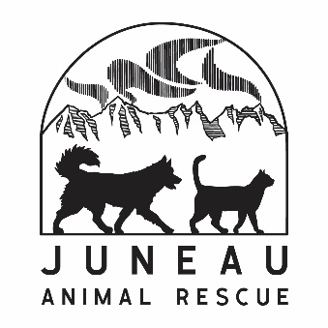

WISH LIST

Cleaning Supplies Dog Supplies
Paper Towels Dog Treats
Dish Soap Hill’s Science Diet Adult Chicken & Barley
Bleach Recipe Dog Food
Dish Sponges Peanut Butter-Creamy
Disinfecting Wipes Kong Classic & Extreme Toys
Tall Kitchen Garbage Gags Nylabone Toys
33 Gallon Black Garbage Bags Tennis Balls
Laundry Pods
Unscented Dryer Sheets Cat Supplies
Wood Pellets (we use them for cat litter)
Office Supplies Hill’s Science Diet Adult Chicken
Copy Paper Recipe Cat Food
3”x3” Post-it Notes Hill’s Science Diet Kitten Chicken Recipe
Postage Stamps (forever)
Small Animal Supplies
Medical Supplies Timothy Hay
Nitrile Exam Gloves (medium & large) Rabbit Food Pellets
Greenies Pill Pockets Guinea Pig Food Pellets
Ferret Food
Miscellaneous Supplies Toys
Toilet Paper Newspaper
Facial Tissue
Quart Size Ziplock Bags Gift Cards
Gallon Size Ziplock Bags Costco
Gently Used Bath Towels Fred Meyer
Gently Used Fleece and Vellux Blankets Home Depot
Amazon

We cannot use food or treats that are expired

